

Management Review

2014
Brett McElligott, HSEQ Manager
Grindrod Shipping

Contents
Safety & Environmental Protection Policy and Objectives 3
Internal and External Audits / Inspections 3
Audits Internal and External 3
Analysis of Internal Audits 4
SIRE Vetting Inspections 5
Overview of SIRE’s completed 5
Analysis of SIRE Observations 5
Analysis of Incidents and Near misses 7
Incidents 7
Near Miss 10
Safety Performance 13
Environmental Performance 14
Port State Control 15
Customer Feedback / Complaints 16
Tanker Management - self‐assessment (TMSA) 16
Risk Assessments 16
Security 16
Suitability and effectiveness of the HSEQ system 17
Review of training needs 17
Performance Indicators 18

Safety & Environmental Protection Policy and Objectives

Grindrod Shipping PTE. Ltd is a leading global provider of shipping operations. It is recognised that our services, lead to an improved quality of life.
It is Grindrod Shipping’s policy to:
- Care for its people and provide safe and healthy working conditions;
- Protect and conserve the environment in which we operate;
- Maintain the highest standard of integrity; and
- Provide our customers with services that most closely meet their requirements and expectations.

Internal and External Audits / Inspections

Audits Internal and External
The following external audits were completed onboard the vessels and Unicorn Office during 2014
External Audit Type | No. Of Audits | No. of NCR | No. Observations
ISPS | 2 | 0 | 0
ISM | 2 | 0 | 0
MLC | 2 | 0 | 0
ISO9001 | 0 | 0 | 0
ISO14001 | 0 | 0 | 0
DOC (IOM+MPA) | 1 | 1 | 0
The following internal audits were completed onboard the vessels during 2014
Internal Audit Type | No. Of Audits | No. of NCR | No. Observations
ISPS | 9 | 1 | 7
ISM | 9 | 13 | 31
Navigation | 2 | 0 | 11

Analysis of Internal Audits
The following analysis of the audits was completed. Please note that for analysis purposes the audit findings are usually entered in BASSnet and split into the same areas as is found in SIRE vetting reports. Unfortunately BASSnet has been slow in uptake and use within the Office and onboard the vessels due to the complexities associated with the BASSnet program and the installation onboard especially newbuild vessels. This has been reviewed by the Company Management and Mr Subramani Iyer –Marine Applications Manager has been inducted. Mr Iyer has vast experience having worked with Bassnet Applications and will oversee the problems with Bassnet and implement the application across the Fleets. The full detail of the Observation and Non Compliances will as of 2015 be available in BASSNet. The Masters are not as efficient as they should be with appropriate and valid closeout of observations and NCN’s. On occasion the Masters do not reply to the remarks, these then become overdue. The Ship Manager is to actively ensure that the vessel closes out all NCN’s and observations appropriately.

As can be seen from the Results of the Audits conducted within the Fleet during 2014 there have been nil findings of deficiencies on board the vessels by DNV the External Auditors.
Internal Audits were conducted during the year on board nine vessels of the Fleet and the findings are essentially pertaining to Sections 04 Navigation, Section 05 Company Safety Procedures, Ship Security Procedures and Bulk Cargo loading and carriage. These are being addressed by induction of additional guidance via Circulars and training material and the induction of Marine Superintendents who will contribute to additional shipboard audits and training on board.

Analysis of Incidents and Near misses

Incidents
There were 66 incidents for Grindrod in 2014, This covers both the IVS and Unicorn Fleets. As lessons learned are distributed to both fleets and usually common to both fleets, the analysis does include both fleets where relevant. The following incidents below are a summary of the most severe incidents for 2014 for the IVS Fleet.
The following occurred in the IVS Fleet for 2014:
Spills:
There were no spills in the IVS Fleet for 2014

Losses:
LAKE TRIVIEW: May
Lake Triview was damaged when she dragged her anchor in rough seas off Port Taranaki New Zealand. Her hull was punctured in at least twelve places. No fuel oil was lost, the environment was not damaged. No crew were injured. The vessel sailed to China for permanent repairs. Lake Triview resumed commercial operations mid August. This is the subject of a P&I claim.
+

LTI’s (severe):

IVS SENTOSA January

Crew slipped from cargo hold vertical ladder during hold cleaning at sea and whilst descending into cargo hold from a height of 4-5 meters. He sustained head injury and bleeding from an open wound on the head and had severe pain in the back and buttock area due to the fall impact. The vessel deviated at sea from her route and called at Salvador, Brazil. Patient was disembarked by helicopter off Salvador and examined by Doctor ashore. He was returned on board after 8 hours. The Doctor declared he had no major injury and could resume normal duty after a few days rest.

IVS IBIS November
LTI: Crew member suffered an emotional breakdown and had to be repatriated to his home country for further medical examination and treatment.

IVS ORCHARD November
MTC: The 2/0 twisted his ankle in the routine process of climbing a ladder to the Monkey Island. This was nothing more than a negligent slip and he did not sign off –the Doctor prescribed rest, which he took on board whilst carrying out Duty (light duty).
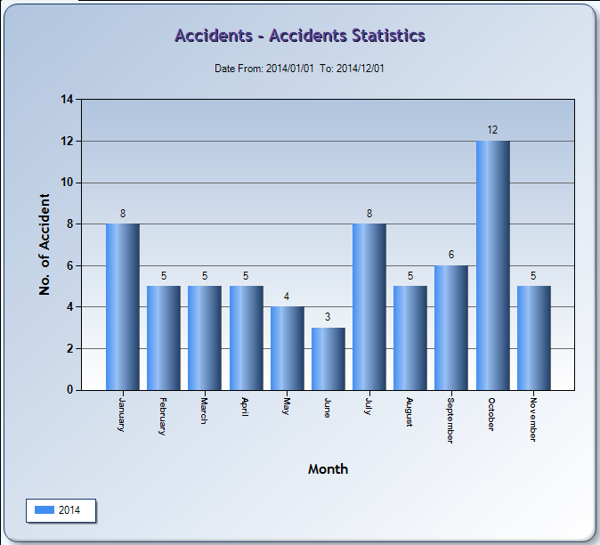
Incidents by month

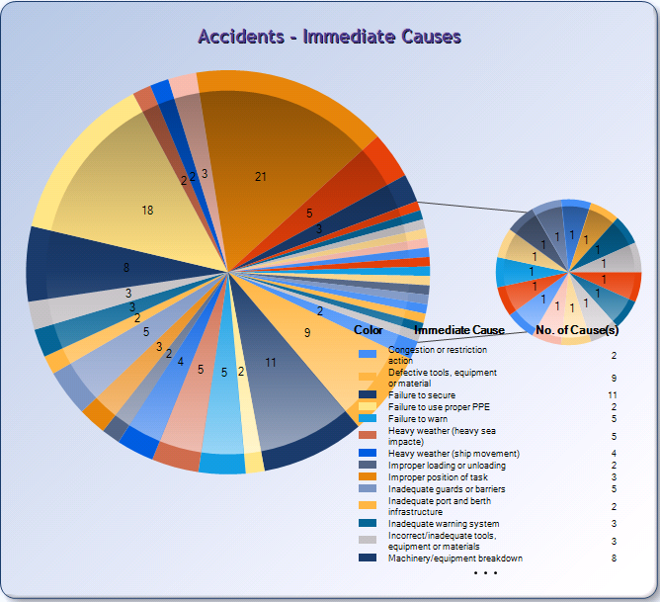 | The top three Immediate causes of Incidents include:  - 15.8% Procedural Error  - 13.5% Machinery and Equipment Failure  - 08.3% Failure to secure  In summary - 24% Immediate causes of incidents is directly attributable to human error and lax practices on the crew’s behalf.
Incidents – Immediate Causes
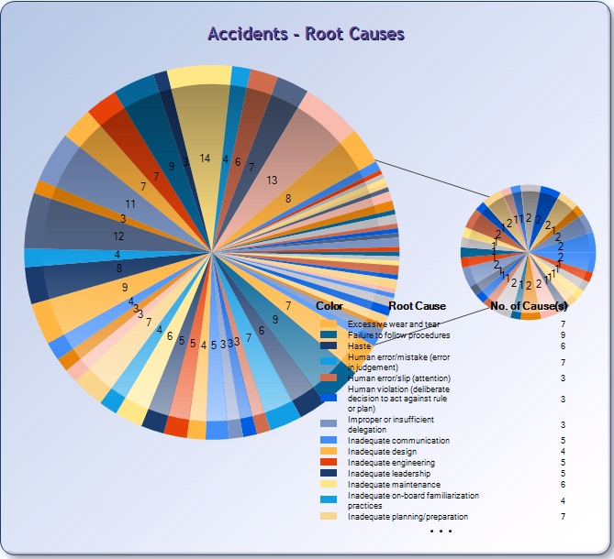 | The top four Root causes of Incidents include:  - 5.8% Lack of situational awareness  - 5.2% Poor design  - 4.8% Incorrect judgment  - 4.4% Failure to follow procedures  In summary - 15% Root causes of incidents is directly attributable to human error which may have its origins in lack of thorough and proper training. Hence the need for good role models within the Senior Management team onboard which will guide and nurture the next generation of officers.
Incidents – Root Causes

Near Miss
A total of 441 near misses were raised during 2014. This is a 90% increase in the amount of near misses raised in the first eleven months of 2013 (233 near misses). Whilst the 2014 total is not near what it should be, the extensive education of the SMT onboard and the use of the more traditional “mail box” system which the near miss papers are inputted by the Officers onboard have led to an increase in near miss reporting.
Further education in the use of the “Fast track wizard” in BASSnet for the ease of reporting will lead to further reporting of near misses. Near Misses are also being reported from the Dry Fleet (not part of said calculations), where applicable the “Lessons learned” in BASSnet are being distributed to both fleets. These are then being read out during the Safety Management Committee meetings held onboard.

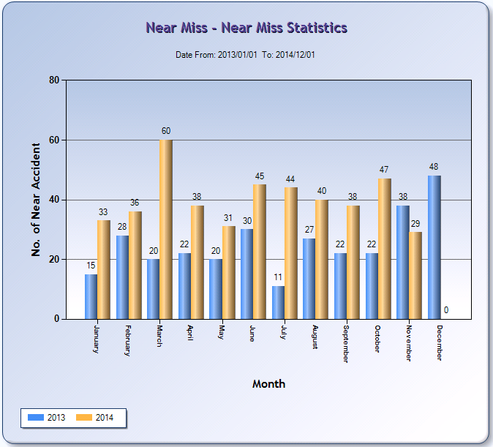

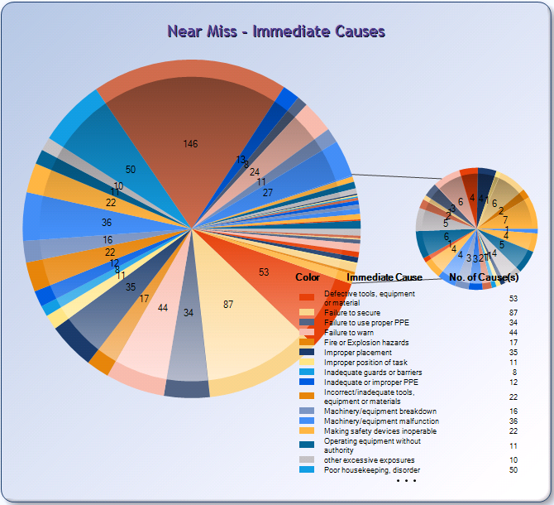 | The top four Immediate causes of Near Misses include:  - 18.8% Procedural error  - 11.2% Failure to secure  - 6.8% Defective tools, equipment or material  - 5.7% Poor housekeeping, disorder  In summary – 35.7% Intermediate causes of incidents is directly attributable to human error which may have its origins in lack of thorough and proper training. Hence as previously stated, the need for good role models within the Senior Management team onboard which will guide and nurture the next generation of officers.
Near Miss - Intermediate Causes

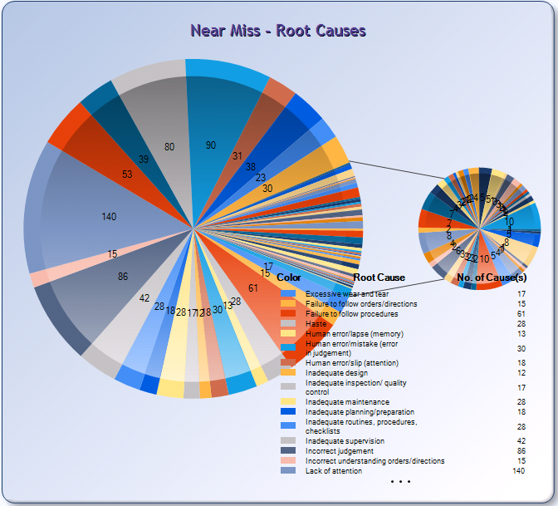 | The top six Root causes of Near Misses include:  - 11.8% Lack attention  - 8.1% lack of knowledge  - 6.8% Incorrect judgment  - 6.8% Lack of situational awareness  - 6.1% lack of experience  - 5.9% Failure to follow procedures  These are all put down to human error. Reinforcement and Monitoring of procedures by the SMT onboard is essential for the reduction in human error through proper policing and education of the crew onboard.
Near Miss – Root Causes

Safety Performance

LTIFR
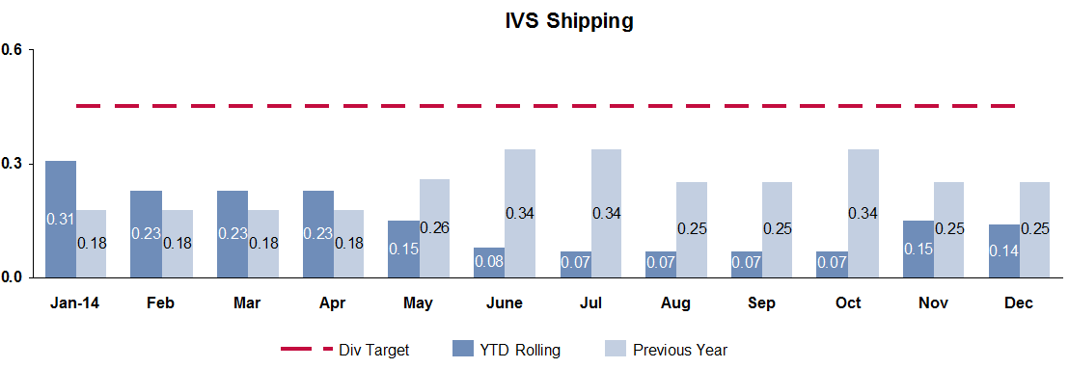
Overall safety performance

KPI | Period | Jan  ‘14 | Feb | Mar | Apr | May | Jun | Jul | Aug | Sep | Oct | Nov | Dec
Fatality  (YTD per calendar) | Actual | - | - | - | - | - | - | - | - | - | - | - | -
Fatality  (YTD per calendar) | PY | - | - | - | - | - | - | - | - | - | - | - | -
LTIFR  (YTD rolling average) | Actual | 0.31 | 0.23 | 0.23 | 0.23 | 0.15 | 0.08 | 0.07 | 0.07 | 0.07 | 0.07 | 0.15 | 0.14
LTIFR  (YTD rolling average) | Target | 0.45 | 0.45 | 0.45 | 0.45 | 0.45 | 0.45 | 0.45 | 0.45 | 0.45 | 0.45 | 0.45 | 0.45
LTIFR  (YTD rolling average) | PY | 0.18 | 0.18 | 0.18 | 0.18 | 0.26 | 0.34 | 0.34 | 0.25 | 0.25 | 0.34 | 0.25 | 0.25
LTIFR  (YTD rolling average) | vs. target (%) | (31) | (49) | (49) | (49) | (67) | (82) | (84) | (84) | (84) | (84) | (67) | (69)
LTIFR  (YTD rolling average) | vs. PY (%) | 72 | 28 | 28 | 28 | (42) | (76) | (79) | (72) | (72) |  |  | (22)

KPI | Comment by exception
Fatality | None
LTIFR | Remains below target and under control. Education measures regarding working with mechanical tools being completed onboard.
Safety incidents and injuries have been reported by e-mail to the Ship manager and crewing department. However on occasion the same has not been reported into BASSNet. The Ship Managers are to ensure that all incidents and near misses which are reported in e-mails, Safety Committee minutes or other reports are also reported in BASSNet.

Environmental Performance
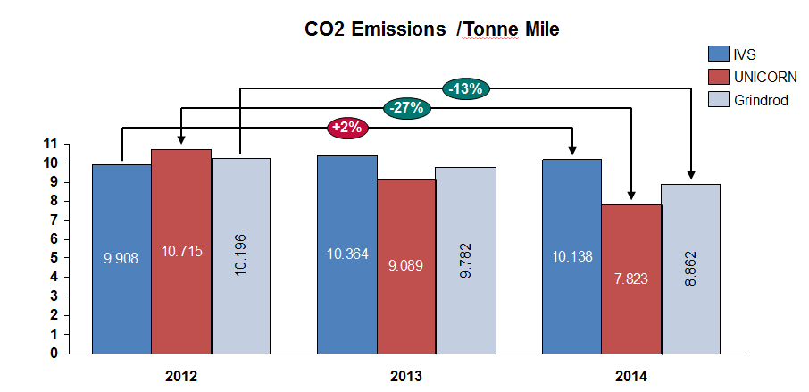
The decrease in CO2 Emissions / Tonne Mile has shown a significant decrease (-27%) compared to the 2012 figures. There are a number of factors which have attributed to this. The first factor is the reduction of the length of ballast voyages and the increase in the amount of cargo being transported. This can be clearly illustrated in the graph below:
It should be noted that the comparison is made between a 38 000 tonne ECO class vs a 40 000 tonne Kanda class burning HFO. Other factors include the efficiencies gained by having a more eco-friendly design in the ECO Class vessels. This does also represent improvements in the way fuel is consumed by the power plants onboard the ECO class vessels. The slight downturn in the graph is due to the Vessels being at anchorage for a period of time
Ship Managers have also been educating the Engineering Crew during their visits to the vessels. Questions have been asked as to why the Main Engine remains on standby when it should be shut down. It is a process of education of the seafarers on conservation of energy but correct shutdown of propulsion machinery etc. which has helped save fuel.
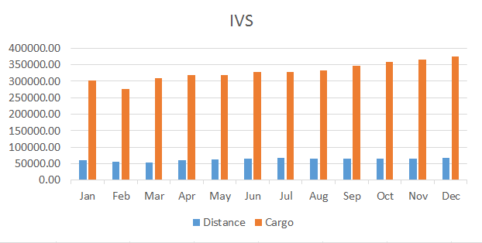 | 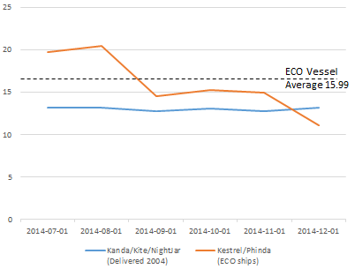
Amount of cargo being transported (orange) vs Distance travelled in Ballast (blue) in 2014. | Performance of the Kestrel vessels compared to the Kanda Class vessels.
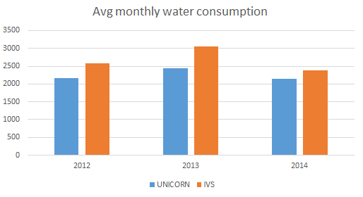 | Average water consumption has remained on the same levels as 2012. There was an increase in 2013. It should be noted however this is very dependent on cargoes carried and how much tank washing is required for consecutive dissimilar cargoes. Active measures and education is in force for the domestic consumption of water.

Port State Control
IVS vessels continue to be the subject Port state control inspections. Largely these have not been an issue, with the exception of two PSC Inspections:
IVS Merlion Pelintung 05/02/2014. The vessel sailed to Pelintung Indonesia. Unfortunately the PSC were trying to receive a bribe which is against the Grindrod Ethics. When no money was forthcoming an enhanced survey was completed with 8 observations. These are without substance and were closed out prior to departure.
IVS KNOT Novorossiysk 03/10/2014: Again a vessel was involved with Russian Port State Control. Historically OLIPHANT (Unicorn Fleet) was also the subject of a rather onerous PSC inspection. There were 2 Radio Communications defects and 3 LSA deficiencies. All deficiencies were rectified prior to departure.
The above issues have highlighted the importance of the port state control and not getting any remarks. Furthermore the Ship Manager is to ensure that all PSC remarks are to be closed out timeously. Verification can only be done by means of a second PSC where the close outs are verified. Again this invites yet more scrutiny and possible further remarks from PSC representatives.
Please find below the PSC completed on a quarterly basis. As can be seen the graph indicates a general downward trend with regard to remarks on PSC inspections.
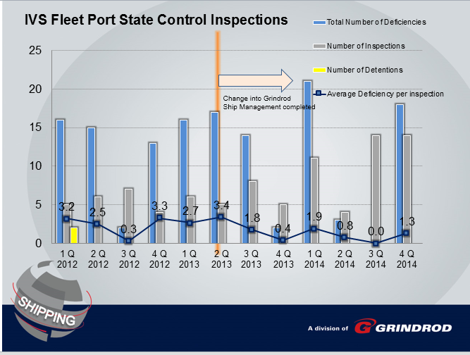

Customer Feedback / Complaints
Lake Triview was involved in a grounding in New Zealand. By all accounts there was some negligence on the part of the Crew. However what is of concern is how the Master conducted himself. He did not report the grounding to the authorities as is the requirement. The hull was punctured in twelve places. At the time of Grounding the vessel management was outsourced to Sandigan Ship Management. Due to the poor performance of Sandigan, it was decided to take the vessel into our Grindrod Management. This was completed Q1 2015.

Risk Assessments
The Risk Assessments continue within BASSNet. However at this time there appears to be a software issue in which all the Master template Risk Assessments have been wiped clean from the Vessel’s databases. BASSnet is investigating and will revert in due course.

Security
All Grindrod vessels comply with International Ship and Port Security (“ISPS”) Code. Furthermore when transiting in a high risk area, anti-piracy measures as described in the Best Management Practices 4 booklet remain in force. This is a requirement of the vessel’s insurance provider. Both Unicorn and IVS Vessels regularly enter into High Risk Areas (HRA) and are employing additional security protection to enhance security on board. When entering the HRA, Singapore Flag is notified and approves the use of security personnel on board.
EBOLA and Maleria remains an issue with vessels travelling to west Africa. A risk assessment has been completed and additional countermeasures put in place. It should be noted that since the commencement of the EBOLA outbreak, our vessels have only visited Lagos Nigeria. There were 20 reported cases in Nigeria with 8 deaths. At this time the outbreak in Nigeria has been contained and no recorded new cases in Nigeria from September 2014. The situation is monitored and the vessels advised should there be any relevant information made available.

Suitability and effectiveness of the HSEQ system
The second half of 2014 has culminated with a re-write of the Safety Management System which was published to the vessels during August 2014. There were significant upgrades completed to all Manuals within the system. The next issue to be completed during the 1st Half of 2015 will be the document control and month end reporting using a more automated process.

Review of training needs
Training is required on the Risk Management Module for the office staff and sea staff. This has been developed and training been conducted during the ship visits done by shore staff. The BASSnet program has also developed an Interactive training program which has been deployed to the vessels for their review.
A new onsigners Induction Program has been rolled out during the last quarter 2014. The Induction program caters for all new crew – from the SMT to the ratings. It is an Introduction to Unicorn/Grindrod and the SMS. All new Crew will be obliged to complete this course prior to acceptance into Unicorn onboard the vessels. The average duration of the course is around 5 hours.
It is envisaged that those existing crew members who wish to be promoted will also be required to complete the course.

Performance Indicators
SAFETY, HEALTH, ENVIRONMENT AND QUALITY (SHEQ

2014 HSE INCIDENT STATUS – HOW ARE WE DOING?
INJURIES AND DEATHS | 2013 | Quarterly Results |  |  |  | 2014
INJURIES AND DEATHS | Results | 1Q | 2Q | 3Q | 4Q | Target | Actual
Deaths | 0 | 0 | 0 | 0 | 0 | 0 | 0
(Unnatural or Accidental)
Lost Time Injury | 3 | 1 | 0 | 0 | 1 | 2 | 2
(Day Away From Work)
Medical Treatment Cases | 2 | 1 | 1 | 0 | 0 | 4 | 2
(External treatment/assistance req'd)
First Aid Cases | 2 | 1 | 4 | 1 | 0 | 7 | 6
(Onboard treatment only)

SPILLS AND EMISSIONS |  | 2013 | Quarterly Results |  |  |  | 2014
 |  | Results | 1Q | 2Q | 3Q | Oct-Nov | Target | Actual
Spill  (Into the Environment) |  | 0 | 0 | 0 | 0 | 0 | 1 | 0
Minor Spill |  | 0 | 0 | 0 | 0 | 0 | 1 | 0
(Contained and < 1 bbl)
Contained Spill |  | 0 | 0 | 0 | 0 | 0 | 2 | 0
(Contained and > 1 bbl)
Spill |  | 0 | 0 | 0 | 0 | 0 | 1 | 0
(Any quantity into the water))
MATERIAL LOSSES |  | 2013 | Quarterly Results |  |  |  | 2014
 |  | Results | 1Q | 2Q | 3Q | Oct-Nov | Target | Actual
Minor Damage / Loss |  | 15 | 0 | 0 | 0 | 0 | 7 | 0
(Less than $5000)
Serious Damage / Loss |  | 3 | 1 | 0 | 0 | 0 | 3 | 1
($5000 to $500000)
Massive Damage / Loss |  | 0 | 0 | 1 | 0 | 0 | 1 | 1
($500 000 TO $1000 000)
Catastrophic Damage/Loss |  | 0 | 0 | 0 | 0 | 0 | 0 | 0
(Greater than $1 000 000)

Quality and Customer Service | 2013 | Quarterly Results |  |  |  | 2014
Quality and Customer Service | Results | 1Q | 2Q | 3Q | Oct-Nov | Target | Actual
Unplanned off hire as a result of our management failure | 3 | 0 | 0 | 0 | 0 | 0 | 0
Cargo Contaminations | 1 | 0 | 0 | 0 | 0 | 0 | 0
Customer Complaints | 1 | 0 | 1 | 0 | 0 | 4 | 1
- Items marked with an asterisk are reflected within the Un-planned off hire records, and are recorded separately for analysis purposes only

Best Practise | 2013 | Quarterly Results |  |  |  | 2014
Best Practise | Results | 1Q | 2Q | 3Q | Oct-Nov | Target | Actual
Near Miss Reports | 233 | 129 | 114 | 122 | 76 | 600 | 441

